

Classify Tweet by gender report

Machine learning assignment 2020

Phillip Madi Alec Mbanga Tshegofatso Aphane Nhlanhla Mpele Mahlatsi | COMS3007A - Machine Learning | June 24, 2020

## **STEP 1: DESCRIPTION OF THE DATASET**

This data is downloaded from the site <https://www.kaggle.com/crowdflower/twitter-user-gender-classification>.

**- What are the attributes? What values do they take on?**

The dataset contains the following fields:

* **unitid**: a unique id for user
* _**golden**: whether the user was included in the gold standard for the model; TRUE or FALSE
* ***unit*state**: state of the observation; one of *finalized* (for contributor-judged) or *golden* (for gold standard observations)
* ***trusted*judgments**: number of trusted judgments (int); always 3 for non-golden, and what may be a unique id for gold standard observations
* ***last*judgment**_at: date and time of last contributor judgment; blank for gold standard observations
* **gender**: one of *male*, *female*, or *brand* (for non-human profiles)
* **gender**:**confidence**: a float representing confidence in the provided gender
* **profile**_**yn**: "no" here seems to mean that the profile was meant to be part of the dataset but was not available when contributors went to judge it
* **profile**_**yn**:**confidence**: confidence in the existence/non-existence of the profile
* **created**: date and time when the profile was created
* **description**: the user's profile description
* **fav**_**number**: number of tweets the user has favorited
* **gender**_**gold**: if the profile is golden, what is the gender?
* **link**_**color**: the link color on the profile, as a hex value
* **name**: the user's name
* **profile*yn*gold**: whether the profile y/n value is golden
* **profileimage**: a link to the profile image
* **retweet**_**count**: number of times the user has retweeted (or possibly, been retweeted)
* **sidebar**_**color**: color of the profile sidebar, as a hex value
* **text**: text of a random one of the user's tweets
* **tweet**_**coord**: if the user has location turned on, the coordinates as a string with the format "[*latitude*, *longitude*]"
* **tweet**_**count**: number of tweets that the user has posted
* **tweet**_**created**: when the random tweet (in the text column) was created
* **tweet**_**id**: the tweet id of the random tweet
* **tweet**_**location**: location of the tweet; seems to not be particularly normalized
* **user**_**timezone**: the timezone of the user

- **What are the targets?**

* The targets are the **gender**: one of *male*, *female*, or *brand* (for non-human profiles).
* We are predicting how well do words in tweets and profiles predict user gender?

- **How many data points do you have?**

* The whole dataset contains **20050** data points

- **Sample data points (4) from the dataset:**

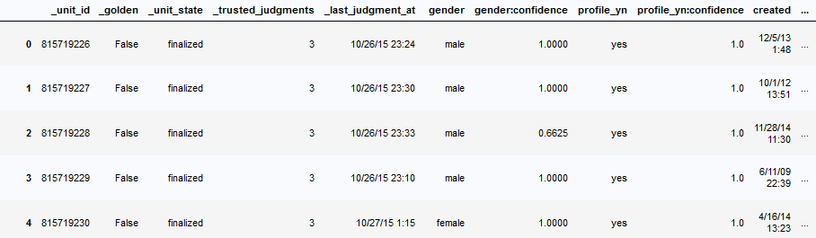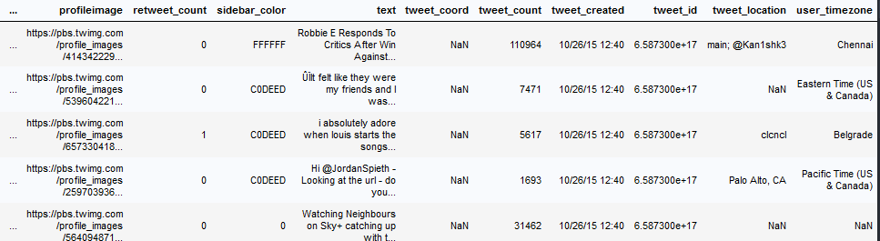

**- State what you are trying to predict with the data?**

* We are predicting how well do words in tweets and profiles predict user gender?

## **STEP 2: DATA PROCESSING AND VISUALISATION.**

- **How was the data pre-processed**?

In NewProcessedData.ipynb:

* Replaced missing values with most frequent value on that feature.
* Changed continues values to discrete categorical values.

In ProcessedData.ipynb:

* Creation of bag of words.
* Got top 4000 words which will act as our features of each sentence.
* Frequency of our features in each datapoint.
* Creation of Sparse Matrix, Design Matrix.

**- How were the inputs/targets normalised?**

**- How was the data split into training/validation/test data?**

* The full set of the data was spilt into 2/3 for **training** and **validation** and 1/3 for **test** data. Each Algorithm furthermore splits the 2/3rds of data according to their preference, which we’ll get to later on.

## **STEP 3: ALGORITHM IMPLEMENTATION**

**Logistic Regression:**

We can apply stochastic gradient descent to the problem of finding the coefficients for the logistic regression model as follows:

Given each training instance:

1. Calculate a prediction using the current values of the coefficients.
2. Calculate new coefficient values based on the error in the prediction.

The process is repeated until the model is accurate enough (e.g. error drops to some desirable level) or for a fixed number iterations. You continue to update the model for training instances and correcting errors until the model is accurate enough and cannot be made any more accurate. It is often a good idea to randomize the order of the training instances shown to the model to mix up the corrections made.

**Naïve Bayes:**

The classifier is given with some features (being a male or female) and it must decide if tweet a male or female (these are two classes). It uses Bayestheorem formula to calculate the probability of each class under the features, and it assigns the class with the highest probability to the input. To provide the required probabilities (90%, 10%, 80%...) it uses the training set. For example, it counts the people in the training set that are males and find they contribute 10% of the sample. In the other words, it tries to build the probability distribution of the features for each class based on the training data.

## **STEP 4: A BRIEF DISCUSSION AND ANALYSIS OF RESULTS FROM THE VARIOUS ALGORITHMS.**

* Some features had continues values and I changed those feature to have discrete values because most classification algorithms can easily work with discrete values and it will also help to increase accuracy. For example in our dataset you can see that the "gender:confidence" feature takes any continues value between 0 and 1, so to make it categorical we added a "discrete-gender:confidence" feature which grouped continues values between 0-0.1 to 'gender:confidence_1', 0.1-0.2 to 'gender:confidence_2', 0.2-0.3 to 'gender:confidence_3',......., 0.9-1 to 'gender:confidence_9'. So now we have just 9 categories inside gender:confidence instead of thousands of continues values between 0 and 1. So on our algorithms we can either use continues 'gender:confidence' or 'discrete-gender:confidence'.